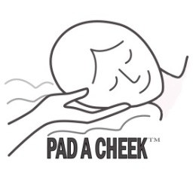
®
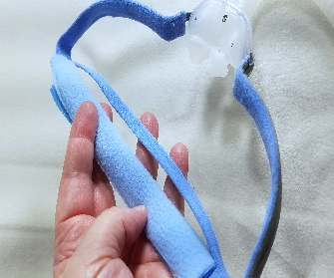
PAD A CHEEK
Strap Pad +
Narrow Strap Cover
AirFit P10, AirFit N30, Evora
Brevida

- These pads are designed to wrap around the headgear strap and secure with the Velcro completely covered.
- They will protect your hair from being pulled by the headgear strap and also keep it from sliding so easily.
- They work for several different mask with narrow headgear straps.
- These pads are 8 inches long and come 2 in a package.
- Wrap the pad around the headgear with either the fleece or the smooth microfiber on the outside. (They are reversible)
- Secure with the Velcro making certain no hook Velcro is sticking out beyond the edges of the pad.
- Smooth out so there are no wrinkles in the pad.

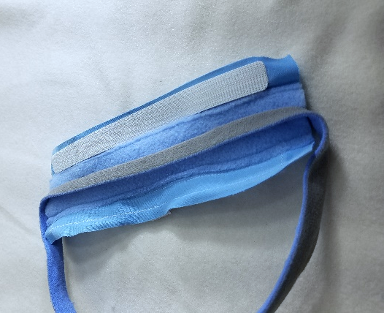
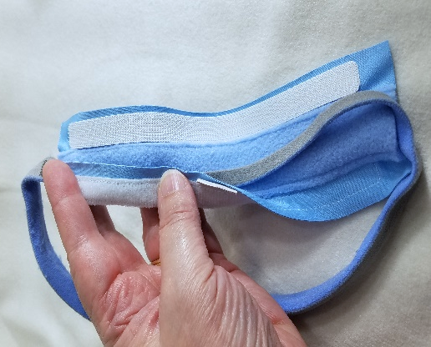
1
2

1
3
4

4
3
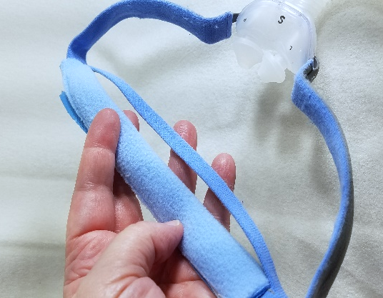
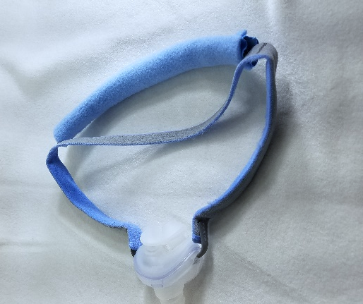

PAD A CHEEK Narrow Strap Cover is polyester mircro fleece and microfiber. They can be machine or hand washed weekly or more frequently if necessary in hot soapy water. It is very durable. If you have questions, please contact us.
PAD A CHEEK LLC 434-985-4003 157 Sunset Drive, Stanardsville, VA 22973
Email: admin@padacheek.com web site: www.padacheek.com Designed and Sewn in the USA

