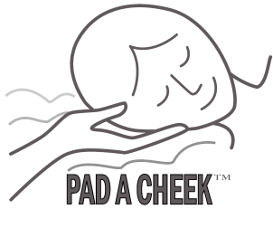
PAD A CHEEK
®
Mask Liner
FFG new
AirFit F30i

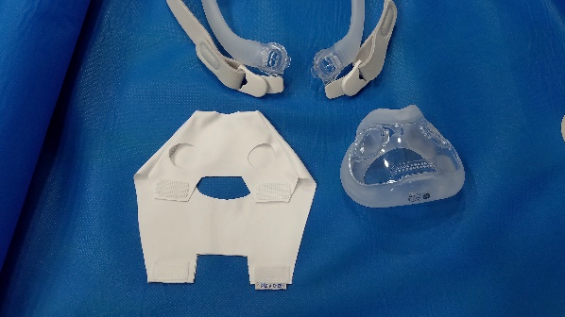
1. Lay the PAD A CHEEK Mask Liner out with the legs pointing down and the two holes visible.
2. Unhook the magnets from the mask on the sides.
3. Place the cushion of the mask under the top layer of the mask liner, face down placing the mouth opening of the mask cushion over the large oval hole in the liner.
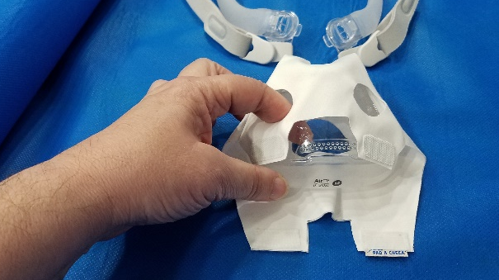
4. The nose hole in the cushion should line up with the smaller hole in the mask liner.
5. Make sure the holes for the headgear line up with the two holes of the mask liner where the finger is going through. Second Photo
7. Pull the legs up and connect the Velcro to secure the mask liner on both sides. Third Photo
8. Re attach the headgear by snapping the clips into the holes on the side of the cushion.
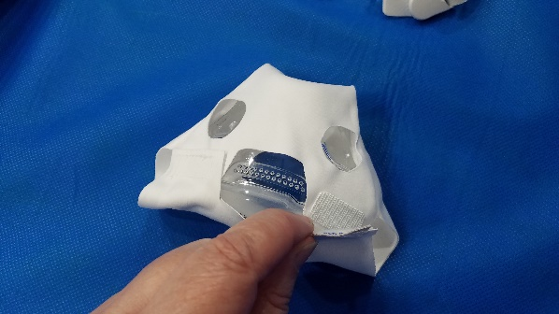
9. If the holes for your nose or mouth is not large
enough, trim the hole a little bit at a time to make it fit. If necessary, trim the rectangular hole near the vents.
Make certain no exhalation vents are covered with the Mask Liner

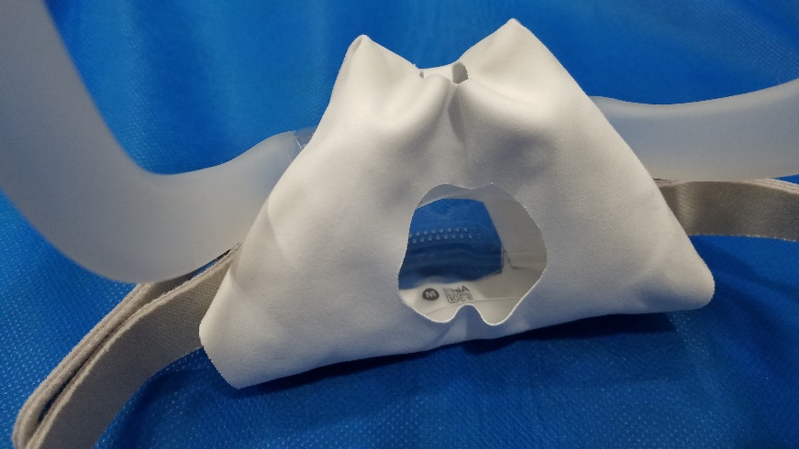
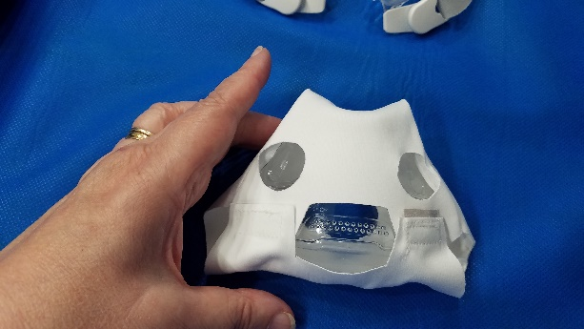

The PAD A CHEEK® Mask Liner is made from polyester micro fiber and should be hand washed with warm soapy water weekly and laid flat to air dry. If you have any questions, please contact us.
PAD A CHEEK® 434-985-4003
157 Sunset Drive, Stanardsville, VA 22973
email admin@padacheek.com web site www.padacheek.com Designed and Sewn in the USA

